SUPERSTORE SALES ANALYSIS
AN END TO END DATA ANALYTICS PROJECT

EKEH NMESOMA AMAZING-GRACE

Prepared by:
Nmesoma Amazing-Grace Ekeh

Project Type
Data Analytics Portfolio Project

Date
July 2026

Table of Contents
ABSTRACT 3
1. INTRODUCTION 4
PROJECT OBJECTIVES 5
2. DATASET OVERVIEW 7
2.1 Dataset Description 7
2.2 Number of Records 7
2.3 Key Variables in the Dataset 7
2.4 Importance of the Dataset 9
2.5 Data Preparation Summary 9
3. METHODOLOGY 12
3.1 Overview 12
3.2 Data Collection 13
3.3 Data Cleaning Using Microsoft Excel 13
3.4 Database Management Using PostgreSQL 14
3.5 Dashboard Development Using Microsoft Power BI 15
3.6 Business Insight Generation 16
4. DATA CLEANING USING MICROSOFT EXCEL 18
4.1 Overview 18
4.2 Importing the Dataset into Microsoft Excel 18
4.3 Removing Duplicate Records 18
4.4 Checking for Missing Values 19
4.5 Standardizing Date Formats 19
4.6 Creating Additional Analytical Columns 20
4.7 Verifying Data Quality 20
4.8 Exporting the Cleaned Dataset 21
5. DATA ANALYSIS USING POSTGRESQL 24
5.1 Overview 24
5.2 Creating the Database 24
5.3 Importing the Dataset 24
5.4 Data Validation 25
5.5 Exploratory Data Analysis (EDA) 25
5.6 Business Questions Answered Using SQL 26
5.7 SQL Queries Used in the Analysis 26
5.8 Contribution of PostgreSQL to the Project 27
6. DASHBOARD DEVELOPMENT USING POWER BI 29
6.1 Connecting PostgreSQL to Power BI 29
6.2 Creating DAX Measures 29
6.3 Building Visualizations 31
7. DASHBOARD OVERVIEW 34
8. KEY FINDINGS 38
8.1 Key Performance Indicators (KPIs) 38
8.2 Sales Performance 38
8.3 Profitability 38
8.4 Product Category Performance 39
8.5 Regional Performance 39
8.6 Customer Segment Analysis 39
8.7 Product Performance 39
8.8 Overall Findings 40
9. BUSINESS INSIGHTS 42
9.1 Overall Business Performance 42
9.2 Technology Products Drive Revenue Growth 42
9.3 The West Region Is the Most Profitable Market 42
9.4 Consumer Customers Contribute the Largest Share of Sales 43
9.5 Sales Increase During the End of the Year 43
9.6 Interactive Dashboard Supports Better Decision Making 43
9.7 Business Value of the Dashboard 44
10. RECOMMENDATIONS 46
10.1 Increase Investment in High Performing Product Categories 46
10.2 Improve Profitability in Lower Performing Regions 46
10.3 Strengthen Customer Retention Strategies 46
10.4 Prepare for Seasonal Demand 47
10.5 Use Business Intelligence for Continuous Monitoring 47
10.6 Continue Data Quality Management 47
10.7 Expand Future Analysis 48
11. CHALLENGES ENCOUNTERED 49
11.1 Data Cleaning Challenges in Microsoft Excel 49
11.2 Challenges Importing Data into PostgreSQL 49
11.3 Database and SQL Challenges 50
11.4 Connecting PostgreSQL to Microsoft Power BI 50
11.5 Creating DAX Measures 51
11.6 Dashboard Design and Visualization 51
11.7 Lessons Learned 52
12. CONCLUSION 53
APPENDIX 55
Appendix A: Data Preparation in Microsoft Excel 55
Appendix B: PostgreSQL Database Implementation 56
Appendix C: SQL Queries 58
Appendix D: DAX Measures 62
Appendix E: Power BI Dashboards 63

ABSTRACT
This project presents an end to end sales analysis of the Superstore dataset using Microsoft Excel, PostgreSQL, and Microsoft Power BI. The objective was to transform raw sales data into meaningful business insights through data cleaning, exploratory data analysis, and interactive dashboard development. Microsoft Excel was used to clean and prepare the dataset by removing duplicates, checking for missing values, formatting dates, and creating additional analytical columns. The cleaned data was then imported into PostgreSQL, where SQL queries were used to explore business performance and calculate key metrics such as total sales, profit, order volume, and category performance. Finally, Power BI was used to create an interactive dashboard featuring KPIs, charts, and slicers that allow users to explore the data dynamically. The findings provide insights into sales trends, regional profitability, customer segments, and top performing products, demonstrating the value of business intelligence in supporting data driven decision making.

Tools Used:
Microsoft Excel • PostgreSQL • Microsoft Power BI

1. INTRODUCTION
In today's business environment, organizations generate vast amounts of data from their daily operations, including sales transactions, customer purchases, inventory records, and financial activities. While this data is valuable, it has little practical use unless it is properly analyzed and transformed into meaningful information. Business Intelligence (BI) plays a crucial role in this process by enabling organizations to collect, analyze, visualize, and interpret data to support informed decision making.
Business Intelligence refers to the technologies, tools, and processes used to convert raw data into actionable insights. Rather than relying on assumptions or intuition, businesses use BI to monitor performance, identify trends, evaluate customer behavior, measure profitability, and make strategic decisions based on accurate and timely information. Modern organizations across industries including retail, healthcare, finance, manufacturing, and education use Business Intelligence to improve efficiency, optimize operations, and gain a competitive advantage.
One of the most common applications of Business Intelligence is the analysis of sales data. Companies analyze sales data to understand how products perform, identify their most profitable customer segments, monitor regional performance, evaluate seasonal trends, and measure overall business growth. Sales analysis enables managers to identify strengths and weaknesses within the business, allocate resources effectively, improve customer satisfaction, and develop strategies that increase revenue and profitability.
Microsoft Power BI has become one of the leading Business Intelligence tools because of its ability to transform complex datasets into interactive dashboards and reports. It allows users to connect data from multiple sources, perform data modeling, create calculations using Data Analysis Expressions (DAX), and develop dynamic visualizations that support real time analysis. Features such as KPI cards, charts, maps, slicers, and drill down capabilities make Power BI an effective tool for communicating business performance to both technical and non technical stakeholders.
This project demonstrates a complete end to end data analytics workflow using the Superstore Sales Dataset. The project began with data cleaning and preparation in Microsoft Excel, where duplicate records were removed, missing values were checked, dates were standardized, and additional analytical columns were created. The cleaned dataset was then imported into PostgreSQL, where SQL queries were used to perform exploratory data analysis (EDA), calculate key business metrics, and validate the dataset. Finally, the processed data was connected to Microsoft Power BI, where DAX measures, KPI cards, interactive charts, and slicers were developed to create a comprehensive sales performance dashboard.
The resulting dashboard provides an overview of key business metrics, including total sales, total profit, total orders, average order value, monthly sales trends, regional profitability, customer segment distribution, product category performance, and the top performing products. Interactive filters enable users to analyze performance by Year, Month, Region, Category, and Customer Segment, making the dashboard flexible and suitable for different business reporting needs.
The primary purpose of this project is to demonstrate the complete data analytics process—from raw data preparation to business intelligence reporting `while showcasing practical skills in Microsoft Excel, PostgreSQL, Power BI, data visualization, and business insight generation. By completing this project, I developed the ability to clean and prepare data, perform SQL based analysis, build interactive dashboards, and communicate findings through clear visualizations and actionable recommendations. This project serves as both a demonstration of technical proficiency and a practical example of how Business Intelligence can support data driven decision making in a retail business environment.

PROJECT OBJECTIVES
The primary objective of this project was to perform an end to end sales data analysis using Microsoft Excel, PostgreSQL and Microsoft Power BI. The project aimed to transform raw sales data into meaningful insights that support data driven decision making while demonstrating the complete data analytics workflow.
The specific objectives of the project were to:
- Clean and prepare the raw Superstore sales dataset in Microsoft Excel by removing duplicate records, checking for missing values, standardizing date formats, and creating additional columns required for analysis.
- Improve the quality and reliability of the dataset to ensure accurate analysis and reporting.
- Import the cleaned dataset into PostgreSQL and organize it within a relational database for efficient storage and management.
- Perform Exploratory Data Analysis (EDA) using SQL queries to understand the dataset, identify trends, and calculate important business metrics such as total sales, total profit, total orders, average order value, product performance, and regional profitability.
- Validate the accuracy of the imported data before proceeding to visualization and reporting.
- Connect PostgreSQL to Microsoft Power BI to create a reliable data source for dashboard development.
- Develop DAX measures to calculate key performance indicators (KPIs), including Total Sales, Total Profit, Total Orders, and Average Order Value.
- Design an interactive Power BI dashboard that presents business performance through KPI cards, charts, and slicers, allowing users to explore data from multiple perspectives.
- Analyze sales performance across different dimensions, including time, product category, customer segment, region, and individual products.
- Generate meaningful business insights from the dashboard to identify sales trends, customer behavior, and high performing products and regions.
- Provide practical recommendations that can help improve sales performance, profitability, and business decision making.
- Demonstrate practical proficiency in Microsoft Excel, PostgreSQL, SQL, and Microsoft Power BI by completing an end to end data analytics project suitable for a professional portfolio.
These objectives guided every stage of the project, from data preparation and database management to dashboard development and business insight generation, ensuring that the final output was both technically sound and valuable for business analysis.

2. DATASET OVERVIEW

2.1 Dataset Description
This project utilized the Superstore Sales Dataset, a widely used retail dataset commonly employed for learning data analytics, SQL, and business intelligence concepts. The dataset contains historical sales transactions from a retail business and provides detailed information about customers, products, sales performance, profitability, shipping, and geographical locations.
The dataset was selected because it represents a realistic business environment and contains sufficient information to perform exploratory data analysis (EDA), sales performance evaluation, customer segmentation, regional analysis, and dashboard development.
Before analysis, the dataset underwent a comprehensive data preparation process in Microsoft Excel to ensure that it was clean, consistent, and suitable for further analysis in PostgreSQL and Microsoft Power BI.

2.2 Number of Records
The cleaned dataset used in this project contains 9,994 sales transactions, representing individual customer orders made over a four year period.
Each record corresponds to a unique sales transaction and includes information about the customer, purchased product, order date, sales value, profit, discount, quantity purchased, shipping details, and geographical location.

2.3 Key Variables in the Dataset
The dataset contains several variables that were used throughout the analysis. The most important variables are summarized below.
Column | Description
Order ID | Unique identifier assigned to each customer order.
Order Date | Date on which the order was placed.
Ship Date | Date the order was shipped to the customer.
Ship Mode | Shipping method used for delivery.
Customer ID | Unique identifier for each customer.
Customer Name | Name of the customer who placed the order.
Segment | Customer category (Consumer, Corporate, or Home Office).
Country | Country where the customer is located.
City | Customer's city.
State | Customer's state or region.
Region | Geographic sales region (Central, East, South, and West).
Product ID | Unique identifier assigned to each product.
Category | Product category (Technology, Furniture, and Office Supplies).
Sub Category | Specific classification of the product within each category.
Product Name | Name of the purchased product.
Sales | Revenue generated from each transaction.
Quantity | Number of units purchased.
Discount | Discount applied to the transaction.
Profit | Profit earned from each transaction.

2.4 Importance of the Dataset
The Superstore dataset provides sufficient information to evaluate different aspects of business performance. By analyzing the available variables, it is possible to:
- Measure the company's total sales and profit.
- Monitor monthly and yearly sales trends.
- Compare product category performance.
- Identify the most profitable regions.
- Analyze customer purchasing behavior across different segments.
- Determine the best selling products.
- Evaluate order volumes and average order values.
- Generate business insights that support strategic decision making.
These variables formed the foundation for the SQL analysis and the interactive Power BI dashboard developed during this project.

2.5 Data Preparation Summary
Before importing the dataset into PostgreSQL, several preprocessing tasks were carried out in Microsoft Excel to improve data quality. These included:
- Removing duplicate records.
- Checking for blank or missing values.
- Standardizing date formats.
- Verifying data consistency across all columns.
- Creating additional analytical columns to support reporting and visualization.
After cleaning, the dataset was imported into PostgreSQL for exploratory data analysis and later connected to Microsoft Power BI to create an interactive sales performance dashboard.

Figure 1: Overview of the Cleaned Superstore Dataset in Microsoft Excel.
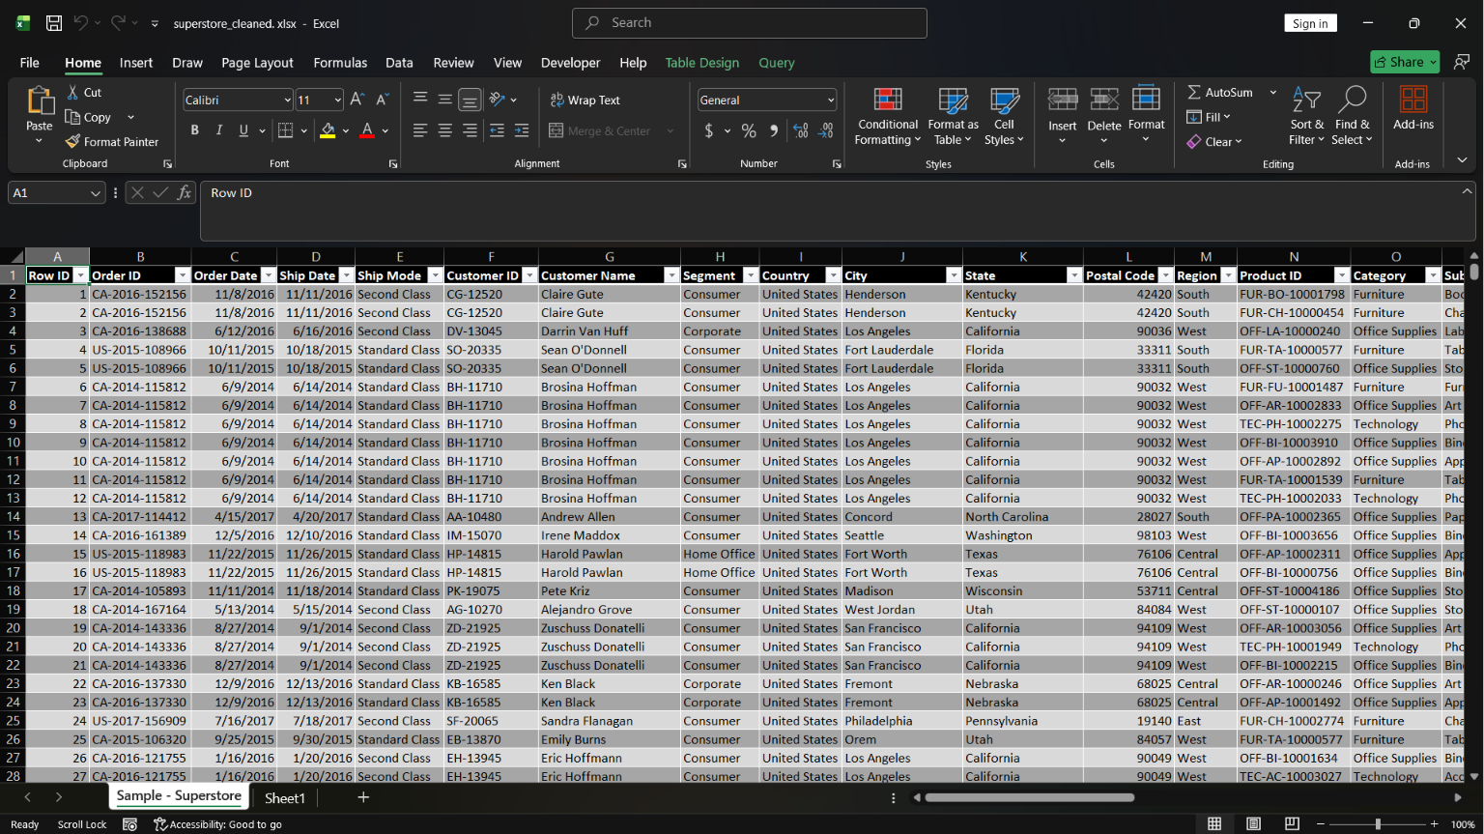

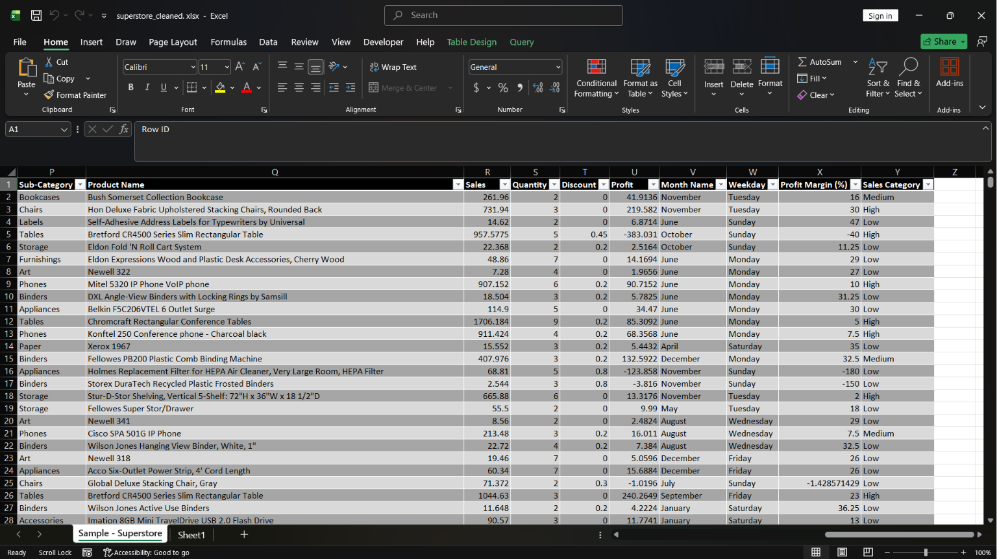

3. METHODOLOGY

3.1 Overview
This project followed a structured data analytics workflow that transformed raw sales data into meaningful business insights through data cleaning, database management, exploratory data analysis, and dashboard development. Three primary tools were used throughout the project: Microsoft Excel, PostgreSQL, and Microsoft Power BI.
The methodology ensured that the data was cleaned, validated, analyzed, and visualized in a systematic manner, resulting in an interactive dashboard capable of supporting business decision making.
The workflow adopted for this project is illustrated below.
Figure 2: Project Workflow
Raw Superstore Dataset
│
▼
Data Cleaning in Microsoft Excel
(Remove duplicates, check blanks, format dates,
create additional analytical columns)
│
▼
Import Cleaned Data into PostgreSQL
│
▼
Exploratory Data Analysis (SQL Queries)
(Sales analysis, profit analysis, product analysis,
regional analysis and customer segmentation)
│
▼
Connect PostgreSQL Database to Power BI
│
▼
Create DAX Measures and Data Model in Power BI
│
▼
Develop Interactive Dashboard and Visualizations
│
▼
Generate Business Insights & Recommendations

3.2 Data Collection
The project utilized the Superstore Sales Dataset, which contains historical retail sales transactions. The dataset includes information relating to customers, products, orders, sales, profit, discounts, shipping details, and geographical locations.
The dataset served as the primary source of information for all analyses performed during the project.

3.3 Data Cleaning Using Microsoft Excel
The first stage of the project involved preparing the dataset in Microsoft Excel to improve data quality before importing it into PostgreSQL.
The following data cleaning tasks were performed:
- Duplicate records were identified and removed to prevent repeated transactions from affecting the analysis.
- Blank or missing values were checked to ensure data completeness.
- Date values were standardized into a consistent format suitable for analysis.
- Additional analytical columns were created where necessary to support reporting.
- The cleaned dataset was reviewed to ensure consistency and accuracy before export.
After the cleaning process was completed, the dataset was saved as a CSV file for import into PostgreSQL.

3.4 Database Management Using PostgreSQL
The cleaned CSV dataset was imported into PostgreSQL to provide a structured database environment for analysis.
Within PostgreSQL, the dataset was successfully imported into the superstore_cleaned table. SQL was then used to validate the imported records and perform exploratory data analysis.
Several SQL functions and clauses were applied throughout the analysis, including:
- SELECT
- WHERE
- GROUP BY
- ORDER BY
- COUNT()
- SUM()
- AVG()
- MAX()
- MIN()
These queries were used to calculate key business metrics such as total sales, total profit, total orders, average order value, category performance, regional profitability, and product performance.

3.5 Dashboard Development Using Microsoft Power BI
Following SQL analysis, PostgreSQL was connected directly to Microsoft Power BI.
The imported dataset was then used to build an interactive dashboard capable of presenting business performance through multiple visualizations.
Several DAX measures were created, including:
- Total Sales
- Total Profit
- Total Orders
- Average Order Value
These measures were used to develop KPI cards and support the calculations displayed throughout the dashboard.
The dashboard includes:
- KPI Cards
- Monthly Sales Trend
- Sales by Category
- Profit by Region
- Customer Segment Distribution
- Top 10 Products by Sales
- Interactive Slicers (Year, Month, Region, Category, and Segment)
These visualizations enable users to interact with the data and explore sales performance across different business dimensions.

3.6 Business Insight Generation
The final stage of the project involved interpreting the dashboard findings to identify patterns and trends in business performance.
Insights were generated by analyzing:
- Overall sales performance
- Regional profitability
- Product category performance
- Customer segment contribution
- Monthly sales trends
- Top performing products
Based on these findings, practical recommendations were proposed to support strategic decision making and improve business performance.

Figure 3: End to End Analytics Process
Raw Data (Excel)
│
▼
Data Cleaning
│
▼
CSV Export
│
▼
PostgreSQL Database
│
▼
SQL Analysis (EDA)
│
▼
Power BI Connection
│
▼
DAX Measures
│
▼
Interactive Dashboard
│
▼
Business Insights
│
▼
Recommendations

4. DATA CLEANING USING MICROSOFT EXCEL

4.1 Overview
Data cleaning is one of the most important stages in the data analytics process because the quality of the analysis depends on the quality of the data. Raw datasets often contain duplicate records, inconsistent formatting, missing values, and other issues that can lead to inaccurate results if not addressed.
For this project, Microsoft Excel was used as the primary tool for preparing the Superstore Sales Dataset before it was imported into PostgreSQL. The objective was to ensure that the dataset was accurate, complete, and suitable for analysis and visualization.
Several data cleaning techniques were applied to improve the reliability of the dataset.

4.2 Importing the Dataset into Microsoft Excel
The Superstore Sales Dataset was first opened in Microsoft Excel. The dataset contained multiple columns describing customer orders, products, sales, profits, shipping details, and geographical information.
After loading the dataset, each column was reviewed to understand the type of information it contained and to identify any inconsistencies that could affect subsequent analysis.

4.3 Removing Duplicate Records
Duplicate records can distort business metrics such as total sales, profit, and order count by counting the same transaction more than once.
To prevent this issue, the dataset was examined for duplicate entries using Excel's Remove Duplicates feature.
The following steps were performed:
- Selected the entire dataset.
- Navigated to the Data tab.
- Clicked Remove Duplicates.
- Selected all relevant columns for duplicate detection.
- Removed duplicate records where applicable.
This process ensured that each transaction in the dataset represented a unique record.

4.4 Checking for Missing Values
Incomplete data can reduce the accuracy of analysis and lead to misleading conclusions.
The dataset was carefully inspected for blank or missing values across all columns.
This involved:
- Reviewing each column for empty cells.
- Confirming that mandatory fields such as Order ID, Order Date, Sales, Profit, Category, and Region contained valid data.
- Verifying that no critical information was missing before proceeding to the analysis stage.
No significant missing values that would affect the analysis were identified after the cleaning process.

4.5 Standardizing Date Formats
The Order Date column is essential for analyzing monthly and yearly sales trends. To ensure consistency, the date values were converted into a standardized date format recognized by both PostgreSQL and Power BI.
Standardizing the date format made it possible to:
- Sort records chronologically.
- Create monthly sales trend charts.
- Filter data by year and month.
- Perform time series analysis in Power BI.

4.6 Creating Additional Analytical Columns
To enhance reporting and dashboard development, additional columns were created in Excel.
These included:
- Month: Extracted from the Order Date to support monthly trend analysis.
- Profit Margin: Used to evaluate the relationship between sales and profit.
- Sales Category: Classified sales values into High, Medium, and Low categories for easier comparison.
These derived columns simplified subsequent analysis and visualization in Power BI.

4.7 Verifying Data Quality
Before exporting the dataset, a final review was conducted to ensure that:
- Duplicate records had been removed.
- Blank values had been addressed.
- Date formats were consistent.
- Numeric columns contained valid values.
- Text fields were correctly formatted.
- All records were complete and suitable for import into PostgreSQL.
This validation step helped reduce the likelihood of import errors and ensured the integrity of the data throughout the project.

4.8 Exporting the Cleaned Dataset
Once the cleaning process was completed, the dataset was saved in CSV (Comma Separated Values) format.
Saving the file as a CSV allowed it to be imported into PostgreSQL without compatibility issues and provided a structured format for SQL analysis.
The cleaned dataset served as the foundation for the remaining stages of the project, including database management, exploratory data analysis, and dashboard development.
Figure 4: Cleaned Superstore Dataset in Microsoft Excel
Figure 4: Cleaned Superstore Dataset in Microsoft Excel

Figure 4 shows the cleaned version of the Superstore dataset after duplicate records were removed, missing values were checked, date formats were standardized, and additional analytical columns were created. This prepared dataset was subsequently exported as a CSV file and imported into PostgreSQL for further analysis.

5. DATA ANALYSIS USING POSTGRESQL

5.1 Overview
After cleaning and preparing the Superstore Sales Dataset in Microsoft Excel, the next stage of the project involved importing the dataset into PostgreSQL for database management and exploratory data analysis (EDA). PostgreSQL is a powerful open source relational database management system (RDBMS) that enables efficient storage, querying, and analysis of large datasets using Structured Query Language (SQL).
Using PostgreSQL allowed the dataset to be organized in a structured database environment, making it easier to retrieve information, calculate business metrics, and identify meaningful trends that would later be visualized in Microsoft Power BI.

5.2 Creating the Database
The first step was to create a new PostgreSQL database to store the cleaned Superstore dataset.
A database named Superstore was created in pgAdmin, providing a dedicated workspace for managing the project data. Within this database, a table named superstore_cleaned was created to store the imported sales records.
Creating a separate database helped organize the project and ensured that all SQL operations were performed within a structured environment.

5.3 Importing the Dataset
After completing the data cleaning process in Microsoft Excel, the dataset was saved in CSV (Comma Separated Values) format to ensure compatibility with PostgreSQL.
The CSV file was imported into the superstore_cleaned table using pgAdmin's Import/Export Data feature. During the import process, the appropriate file path, delimiter (comma), and header options were specified to ensure that the data was imported correctly.
Several import challenges were encountered during this stage, including file path errors and CSV formatting issues. These problems were resolved by correcting the file path, saving the dataset in the proper CSV format, and verifying the import settings. Once these issues were addressed, the dataset was successfully imported into PostgreSQL.

5.4 Data Validation
Following the import process, the dataset was validated to ensure that all records had been imported successfully and accurately.
Basic SQL queries were executed to verify the contents of the table and confirm that the data matched the cleaned Excel dataset.
Examples of validation queries included:
- Displaying all records in the table.
- Counting the total number of records.
- Checking that important columns contained valid values.
- Reviewing sample records for consistency.
This validation step confirmed that the database was ready for further analysis.

5.5 Exploratory Data Analysis (EDA)
Exploratory Data Analysis (EDA) was performed using SQL queries to summarize the dataset and answer key business questions.
The analysis focused on measuring sales performance, profitability, customer purchasing behavior, regional performance, and product performance.
Several SQL functions and clauses were used throughout the analysis, including:
- SELECT – Retrieved specific columns and records from the dataset.
- WHERE – Filtered records based on specified conditions.
- GROUP BY – Grouped records for summarized analysis.
- ORDER BY – Sorted query results in ascending or descending order.
- SUM() – Calculated total sales and total profit.
- COUNT() – Counted the total number of orders and records.
- AVG() – Calculated average sales and average order value.
These SQL operations enabled efficient analysis of the retail sales data and produced the metrics required for dashboard development.

5.6 Business Questions Answered Using SQL
SQL queries were used to answer several important business questions, including:
- What is the total sales revenue generated by the business?
- What is the total profit earned?
- How many customer orders were processed?
- What is the average order value?
- Which product categories generate the highest sales?
- Which regions generate the highest profit?
- Which customer segment contributes the most revenue?
- Which products are the top selling products?
- How does sales performance change over time?
The results obtained from these queries formed the basis for the key performance indicators (KPIs) and visualizations developed in Microsoft Power BI.

5.7 SQL Queries Used in the Analysis
Throughout the project, SQL queries were written to retrieve and summarize data from the superstore_cleaned table.
Typical queries included:
- Retrieving all records from the table.
- Counting the total number of orders.
- Calculating total sales and profit.
- Calculating average sales values.
- Grouping sales by category and region.
- Ranking products based on sales performance.
- Summarizing customer segment performance.
These queries transformed raw transactional data into meaningful business information that supported informed decision making.

5.8 Contribution of PostgreSQL to the Project
Using PostgreSQL provided several advantages during the project:
- Improved organization and storage of the cleaned dataset.
- Faster querying of large amounts of data.
- Accurate calculation of business metrics using SQL.
- Easy integration with Microsoft Power BI.
- Reliable validation of data before visualization.
The use of PostgreSQL demonstrated how relational databases can support business intelligence by providing a structured environment for data analysis and reporting.

Figure 5: Superstore Dataset Imported into PostgreSQL
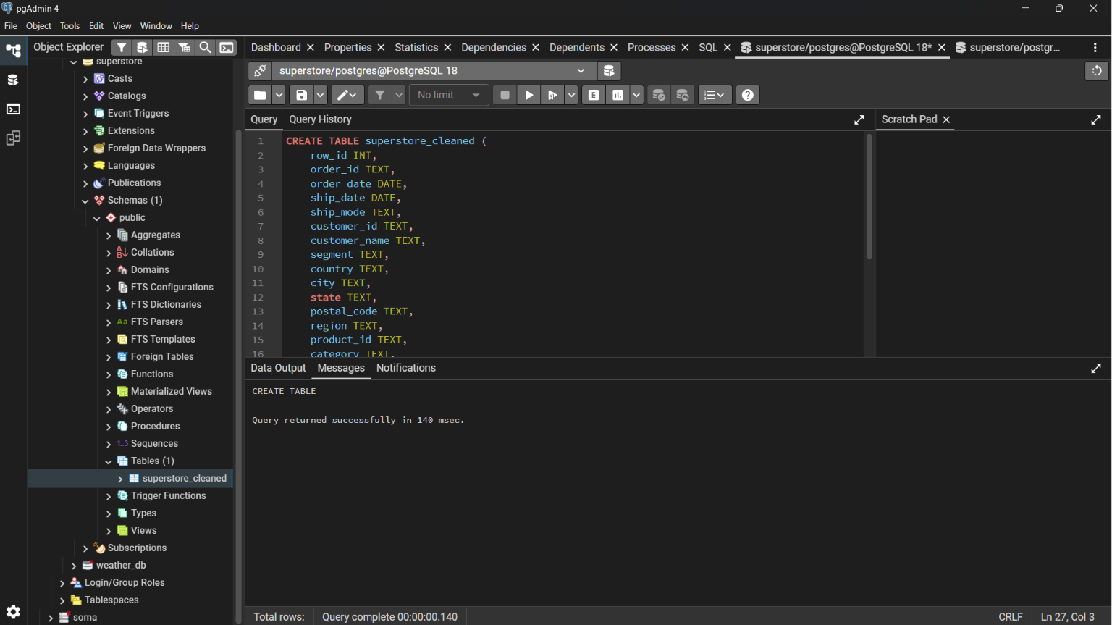
Figure 5. The Superstore Sales dataset successfully imported into PostgreSQL (pgAdmin), where SQL queries were used to perform exploratory data analysis and generate key business metrics.

6. DASHBOARD DEVELOPMENT USING POWER BI
After cleaning and preparing the dataset in Microsoft Excel and storing it in PostgreSQL, the final stage of the project involved creating an interactive dashboard in Microsoft Power BI. The dashboard was designed to present key business metrics visually, making it easier to monitor sales performance, profitability, customer segments, regional performance, and product trends.

6.1 Connecting PostgreSQL to Power BI
The cleaned dataset stored in PostgreSQL was connected directly to Microsoft Power BI.
The connection process involved:
- Opening Power BI Desktop.
- Selecting Get Data → PostgreSQL Database.
- Entering the PostgreSQL server name and database name.
- Authenticating using the PostgreSQL username and password.
- Importing the public.superstore_cleaned table into Power BI.
Connecting directly to PostgreSQL ensured that Power BI could access the cleaned and structured data for visualization and analysis.

6.2 Creating DAX Measures
To summarize business performance, several DAX (Data Analysis Expressions) measures were created.
Total Sales
This measure calculates the total revenue generated from all orders.
Total Sales =
SUM('public superstore_cleaned'[sales])
Purpose:
Displays the overall sales generated by the company.

Total Profit
This measure calculates the total profit earned from all sales.
Total Profit =
SUM('public superstore_cleaned'[profit])
Purpose:
Shows the company's profitability after sales.

Total Orders
This measure counts the number of unique customer orders.
Total Orders =
DISTINCTCOUNT('public superstore_cleaned'[order_id])
Purpose:
Determines how many orders were processed.

Average Order Value
This measure calculates the average revenue generated per order.
Average Order Value =
DIVIDE([Total Sales], [Total Orders],0)
Purpose:
Measures the average amount customers spend on each order.

6.3 Building Visualizations
Several visualizations were developed to communicate business insights effectively.
KPI Cards
Four KPI cards were created at the top of the dashboard to display the most important business metrics.
The cards display:
- Total Sales
- Total Profit
- Total Orders
- Average Order Value
Purpose
These KPIs provide users with a quick overview of overall business performance without needing to analyze multiple charts.

Monthly Sales Trend (Line Chart)
A line chart was created to display Total Sales by Month.
Purpose
This visualization helps identify sales trends throughout the year, making it easy to recognize seasonal patterns, sales growth, and months with higher or lower performance.

Total Sales by Category (Bar Chart)
A horizontal bar chart was created to compare sales across product categories.
The categories include:
- Technology
- Furniture
- Office Supplies
Purpose
This visualization highlights which product category contributes the highest revenue and allows easy comparison among categories.

Total Profit by Region (Column Chart)
A column chart was created to compare profits across different sales regions.
The regions include:
- West
- East
- South
- Central
Purpose
This chart identifies the most profitable and least profitable regions, helping businesses evaluate regional performance.

Total Sales by Product (Bar Chart)
A horizontal bar chart was created to display the best performing products based on sales.
Purpose
This visualization identifies the products generating the highest revenue and helps management understand which products contribute most to overall sales.

Sales by Customer Segment (Donut Chart)
A donut chart was created to show the proportion of sales contributed by each customer segment.
The customer segments include:
- Consumer
- Corporate
- Home Office
Purpose
This chart provides an overview of how sales are distributed among different customer groups and identifies the largest revenue generating segment.

Interactive Slicers
Several slicers were added to improve dashboard interactivity.
The dashboard includes filters for:
- Year
- Month
- Region
- Category
- Customer Segment
Purpose
These slicers allow users to dynamically filter the dashboard and analyze sales performance from different perspectives without modifying the underlying data.

7. DASHBOARD OVERVIEW
This section presents the Power BI dashboards developed for the Superstore Sales Analysis project. The dashboards provide an interactive overview of sales performance, profitability, customer segmentation, product performance, and business insights.

Figure 3. Executive Sales Dashboard
Description
The Executive Sales Dashboard provides a high level overview of the company's sales performance using Key Performance Indicators (KPIs) and interactive visualizations.
Dashboard Components
- KPI Cards
  - Total Sales: $2.30M
  - Total Profit: $286.40K
  - Total Orders: 5,009
  - Average Order Value: $458.61
- Monthly Sales Trend
- Sales by Category
- Profit by Region
- Top Selling Products
Purpose
This dashboard enables decision makers to quickly monitor business performance, identify profitable categories and regions, and understand monthly sales trends.
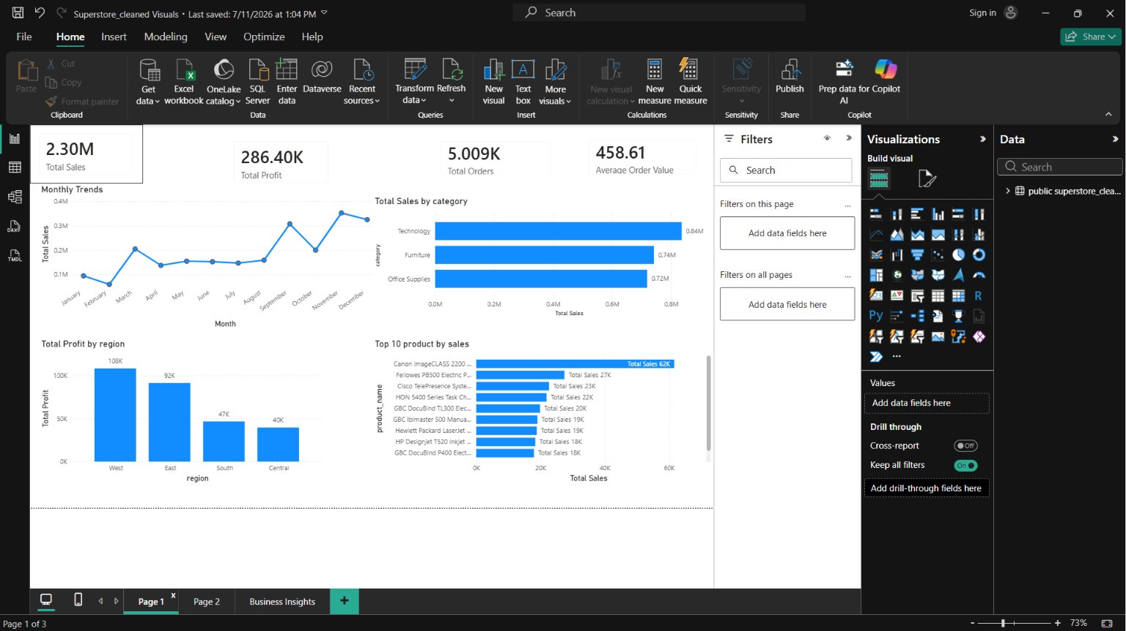
Figure 4. Interactive Filter Dashboard
Description
The Interactive Dashboard enables users to dynamically explore the sales dataset using slicers.
Available Filters
- Year
- Month
- Region
- Category
- Customer Segment
The donut chart automatically updates based on the selected filters, allowing users to analyze customer segment contributions under different conditions.
Purpose
This dashboard improves user interaction and allows detailed exploration of the sales data from multiple perspectives.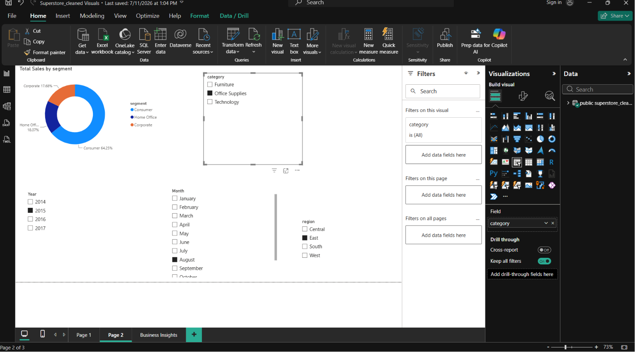
Figure 5. Business Insights Dashboard
Description
The Business Insights page summarizes the major findings from the sales analysis.
The dashboard highlights:
- Total Sales achieved
- Total Profit generated
- Total Orders processed
- Average Order Value
- Highest performing Category
- Most profitable Region
- Largest Customer Segment
- Monthly Sales Trend
- Interactive filtering capabilities
These insights provide management with concise and actionable information to support business decisions.
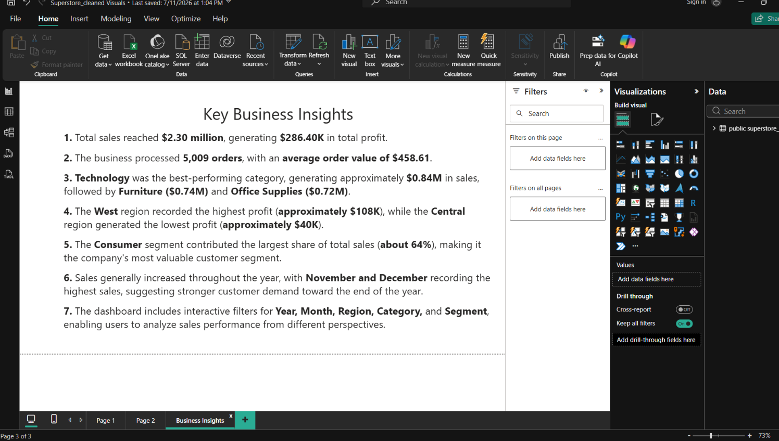

8. KEY FINDINGS
The analysis of the Superstore Sales dataset provided valuable insights into the company's overall sales performance, profitability, customer purchasing behavior, and product performance. The key performance indicators (KPIs) and dashboard visualizations highlight the most important findings derived from the analysis.

8.1 Key Performance Indicators (KPIs)
The table below summarizes the primary business metrics calculated during the project.
KPI | Result | Description
Total Sales | $2.30 Million | Total revenue generated from all sales transactions.
Total Profit | $286.40 Thousand | Total profit earned after accounting for costs and discounts.
Total Orders | 5,009 | Total number of unique customer orders processed.
Average Order Value | $458.61 | Average revenue generated per customer order.
Table 1: Summary of the key performance indicators calculated from the Superstore Sales dataset.

8.2 Sales Performance
The analysis showed that the Superstore generated approximately $2.30 million in total sales during the reporting period. This indicates a strong sales volume and demonstrates the company's ability to generate consistent revenue across different products, customer segments, and regions.
The monthly sales trend further revealed fluctuations in sales throughout the year, with higher sales recorded during the final months of the year, suggesting the influence of seasonal demand.

8.3 Profitability
Although the company generated substantial revenue, the total profit amounted to approximately $286.40 thousand, which is significantly lower than total sales. This suggests that factors such as discounts, operating costs, or product pricing may have affected overall profitability.
The profit analysis also highlighted differences in performance across regions, indicating opportunities for improving profitability in lower performing areas.

8.4 Product Category Performance
Among the three product categories analyzed:
- Technology generated the highest sales.
- Office Supplies contributed steady sales across the reporting period.
- Furniture generated comparatively lower sales and may require further evaluation to improve performance.
This finding suggests that technology products are the primary revenue drivers for the business.

8.5 Regional Performance
The regional analysis indicated differences in profitability across geographical locations.
The West region generated the highest profit, making it the strongest performing region during the analysis period. This suggests effective sales performance and stronger customer demand within that market.
Other regions contributed positively to overall sales but demonstrated comparatively lower profitability.

8.6 Customer Segment Analysis
The dashboard showed that the Consumer segment contributed the largest share of total sales.
This indicates that individual consumers represent the company's largest customer base and should remain a key focus for marketing strategies and customer retention initiatives.
The Corporate and Home Office segments also contributed to sales but accounted for smaller proportions of total revenue.

8.7 Product Performance
The product analysis identified several high performing products that generated substantial revenue for the business.
Understanding which products contribute the most to sales enables management to:
- Prioritize inventory management.
- Improve demand forecasting.
- Develop targeted marketing campaigns.
- Optimize product offerings.

8.8 Overall Findings
The findings from this analysis demonstrate that the Superstore business performs strongly in terms of revenue generation while presenting opportunities to improve profitability and optimize performance across certain regions and product categories.
The integration of Microsoft Excel, PostgreSQL, SQL, and Power BI made it possible to transform raw transactional data into meaningful business insights that can support informed decision making.
Figure 6: Executive Dashboard

Figure 6. Executive dashboard displaying the key performance indicators and visualizations used to evaluate sales performance, profitability, customer segments, product categories, and regional performance.

9. BUSINESS INSIGHTS
The interactive Power BI dashboard provided valuable insights into the company's sales performance, profitability, customer behavior, and regional performance. By analyzing the key performance indicators and visualizations, several important business insights were identified.

9.1 Overall Business Performance
The analysis revealed that the business generated approximately $2.30 million in total sales from 5,009 customer orders, resulting in a total profit of approximately $286.40 thousand. While the company achieved strong sales revenue, the difference between total sales and total profit suggests that profitability may be influenced by factors such as discounts, product costs, or pricing strategies.
Overall, the business demonstrates healthy sales performance with opportunities to further improve profit margins.

9.2 Technology Products Drive Revenue Growth
The dashboard shows that the Technology category generated the highest sales among all product categories.
This indicates that customers have a strong demand for technology related products, making this category the company's primary source of revenue.
This insight suggests that management should continue investing in technology products by ensuring adequate inventory levels, expanding product offerings, and implementing targeted marketing campaigns.

9.3 The West Region Is the Most Profitable Market
Regional analysis revealed that the West region generated the highest profit compared to the East, South, and Central regions.
This suggests that business operations, customer demand, and product performance are strongest within this region.
Understanding the factors contributing to the West region's success may help the company replicate similar strategies in other regions with lower profitability.

9.4 Consumer Customers Contribute the Largest Share of Sales
The customer segment analysis indicates that the Consumer segment contributes the highest proportion of total sales.
This finding suggests that individual consumers represent the company's largest customer base and play a significant role in overall business performance.
Maintaining strong relationships with consumer customers through loyalty programs, personalized promotions, and quality customer service may help sustain future sales growth.

9.5 Sales Increase During the End of the Year
The Monthly Sales Trend visualization shows noticeable growth in sales during the final months of the year, particularly November and December.
This seasonal increase may be associated with holiday shopping, promotional campaigns, or year end purchasing behavior.
Recognizing this trend allows management to prepare for periods of increased demand by improving inventory planning, staffing, and marketing activities.

9.6 Interactive Dashboard Supports Better Decision Making
The dashboard includes interactive slicers that allow users to filter the data by:
- Year
- Month
- Region
- Category
- Customer Segment
These filters enable users to explore business performance from different perspectives without modifying the underlying dataset.
The interactive nature of the dashboard makes it an effective business intelligence tool for monitoring performance and supporting strategic decision making.

9.7 Business Value of the Dashboard
The completed dashboard transforms raw sales data into meaningful visual information that can be easily understood by managers and stakeholders.
Instead of manually reviewing thousands of transaction records, users can quickly identify:
- Overall business performance
- High performing product categories
- Regional profitability
- Customer purchasing patterns
- Monthly sales trends
- Key performance indicators
This improves reporting efficiency and enables faster, evidence based business decisions.

Figure 7: Business Insights Dashboard

Figure 7. Business Insights dashboard summarizing the key findings from the Superstore Sales Analysis, including overall performance, category analysis, regional profitability, customer segmentation, and seasonal sales trends.

10. RECOMMENDATIONS
Based on the findings obtained from the analysis of the Superstore Sales dataset, several recommendations can be made to improve business performance, increase profitability, and support strategic decision making.

10.1 Increase Investment in High Performing Product Categories
The analysis showed that the Technology category generated the highest sales among all product categories. This indicates strong customer demand and highlights Technology as a key driver of revenue.
The company should consider expanding its range of technology products, maintaining adequate inventory levels, and implementing targeted marketing campaigns to capitalize on customer demand. Investing in high performing product categories can help sustain revenue growth and improve overall business performance.

10.2 Improve Profitability in Lower Performing Regions
Although all regions contributed to overall sales, the analysis revealed differences in profitability across regions. While the West region recorded the highest profit, other regions showed comparatively lower performance.
Management should investigate the factors affecting profitability in these regions. Areas for review may include pricing strategies, operational costs, product availability, customer preferences, and promotional activities. Addressing these factors could improve profitability and create a more balanced performance across all regions.

10.3 Strengthen Customer Retention Strategies
The dashboard indicates that the Consumer segment contributed the largest share of total sales, making it the company's most valuable customer group.
To maintain and grow this customer base, the company should implement customer retention initiatives such as loyalty programmes, personalized promotions, and excellent customer service. Retaining existing customers is often more cost effective than acquiring new ones and can contribute to long term business growth.

10.4 Prepare for Seasonal Demand
The monthly sales trend showed increased sales activity towards the end of the year, particularly during November and December. This pattern suggests seasonal demand that may be associated with holiday shopping and promotional events.
The company should prepare for these peak periods by increasing inventory, ensuring adequate staffing, and planning marketing campaigns in advance. Effective preparation can help prevent stock shortages, improve customer satisfaction, and maximize sales opportunities during high demand periods.

10.5 Use Business Intelligence for Continuous Monitoring
The interactive Power BI dashboard developed in this project provides a practical tool for monitoring business performance in real time. Rather than relying on static reports, management can use the dashboard to track key performance indicators, evaluate sales trends, and identify changes in customer behaviour.
Regular use of the dashboard will support faster, evidence based decision making and enable the business to respond proactively to emerging trends and performance issues.

10.6 Continue Data Quality Management
The success of business analysis depends on the quality of the underlying data. Maintaining accurate, complete, and consistent data should remain a priority.
The company should establish routine data quality checks to identify duplicate records, missing values, and formatting inconsistencies before data is used for reporting or analysis. Consistent data management practices will improve the reliability of future analyses and dashboards.

10.7 Expand Future Analysis
This project focused primarily on historical sales performance. Future analyses could be extended to provide deeper business insights by incorporating additional data sources and advanced analytical techniques.
Potential areas for future work include:
- Sales forecasting using historical trends.
- Customer lifetime value analysis.
- Product demand forecasting.
- Profit margin analysis by product.
- Customer churn analysis.
- Predictive analytics using machine learning models.
These advanced analyses could provide management with more proactive decision making tools and support long term business planning.

11. CHALLENGES ENCOUNTERED
Throughout the development of this project, several technical challenges were encountered during the data cleaning, database management, and dashboard development stages. Addressing these challenges provided valuable learning opportunities and strengthened my problem solving skills.

11.1 Data Cleaning Challenges in Microsoft Excel
One of the initial challenges was ensuring that the dataset was suitable for analysis. The dataset was reviewed to identify duplicate records and blank values that could affect the accuracy of the analysis.
Excel's Remove Duplicates feature was used to eliminate duplicate records, while the dataset was carefully examined for missing values and formatting inconsistencies. Date fields were also standardized to ensure compatibility with PostgreSQL and Microsoft Power BI.
These data preparation steps improved the quality and reliability of the dataset before it was imported into the database.

11.2 Challenges Importing Data into PostgreSQL
Importing the cleaned dataset into PostgreSQL proved to be one of the most challenging stages of the project.
Several issues were encountered during the import process, including:
- Incorrect CSV file paths.
- Saving the dataset in the wrong file format.
- Errors caused by incorrect file extensions.
- Import process failures due to configuration settings.
These challenges were resolved by:
- Saving the cleaned dataset as a valid CSV (Comma Separated Values) file.
- Verifying the correct file path before importing.
- Configuring the import settings correctly in pgAdmin.
- Repeating the import process until the dataset was successfully loaded into the public.superstore_cleaned table.
Successfully resolving these issues improved my understanding of data import procedures in PostgreSQL.

11.3 Database and SQL Challenges
While working in PostgreSQL, several SQL related issues were encountered.
One common error occurred when attempting to create a table that already existed, resulting in the following message:
ERROR: relation "superstore_cleaned" already exists
This issue occurred because the table had already been created. The problem was resolved by querying the existing table instead of attempting to recreate it.
Additional challenges included:
- Verifying that data had been imported successfully.
- Understanding PostgreSQL schemas.
- Referencing the correct table (public.superstore_cleaned) in SQL queries.
- Validating imported records before proceeding to dashboard development.
These experiences improved my understanding of relational databases and SQL query execution.

11.4 Connecting PostgreSQL to Microsoft Power BI
Establishing a connection between PostgreSQL and Microsoft Power BI presented another challenge.
Initially, the required table was not visible in Power BI because of connection and navigation issues. After reviewing the database configuration, refreshing the connection, and selecting the correct schema and table, the dataset was successfully imported into Power BI.
This process demonstrated the importance of verifying database connections and ensuring that the correct data source is selected.

11.5 Creating DAX Measures
Developing DAX measures required careful attention to table names, column names, and syntax.
During this stage, errors such as "Cannot find table 'superstore_cleaned'" were encountered because the DAX formulas referenced an incorrect table name.
The issue was resolved by using the correct table name imported into Power BI (public superstore_cleaned) and verifying that each column reference matched the imported dataset.
Successfully creating measures for Total Sales, Total Profit, Total Orders, and Average Order Value improved my understanding of DAX and Power BI calculations.

11.6 Dashboard Design and Visualization
Designing an effective dashboard required selecting appropriate visualizations and arranging them in a way that clearly communicated business performance.
Challenges encountered during this stage included:
- Choosing suitable chart types.
- Formatting KPI cards.
- Sorting charts correctly.
- Configuring slicers.
- Customizing chart titles.
- Organizing visuals into a clear and professional layout.
These challenges were addressed through iterative design improvements, resulting in a dashboard that is visually appealing, interactive, and easy to interpret.

11.7 Lessons Learned
Overcoming these challenges significantly improved my technical skills and confidence in using Microsoft Excel, PostgreSQL, SQL, and Microsoft Power BI.
This project provided practical experience in:
- Data cleaning and preparation.
- Database creation and management.
- SQL querying and troubleshooting.
- Connecting databases to Power BI.
- Writing DAX measures.
- Building interactive dashboards.
- Interpreting data to generate business insights.
Each challenge strengthened my ability to troubleshoot technical issues and reinforced the importance of patience, attention to detail, and systematic problem solving throughout the data analytics process.

12. CONCLUSION
This project successfully demonstrated the complete data analytics process, from data preparation to business intelligence reporting, using Microsoft Excel, PostgreSQL, SQL, and Microsoft Power BI. The Superstore Sales dataset was transformed from raw transactional data into an interactive dashboard that provides meaningful insights into business performance.
The project began with data cleaning in Microsoft Excel, where the dataset was reviewed to remove duplicate records, check for missing values, and standardize data formats. These preprocessing activities ensured that the data was accurate, consistent, and suitable for further analysis.
Following the cleaning stage, the dataset was imported into PostgreSQL, where it was stored in a relational database and analyzed using SQL. Various SQL queries were executed to validate the imported data and calculate key business metrics, including total sales, total profit, total orders, and average order value. Additional analyses were performed to evaluate product categories, customer segments, regional performance, and sales trends.
The cleaned and validated dataset was then connected to Microsoft Power BI for dashboard development. Using DAX measures and interactive visualizations, a business intelligence dashboard was created to present the analysis in a clear and user friendly format. The dashboard allows users to monitor key performance indicators, explore sales trends, compare regional performance, and analyze customer purchasing behavior through interactive filters and charts.
The analysis revealed several important findings. The Technology category generated the highest sales, the West region recorded the highest profit, and the Consumer segment contributed the largest share of revenue. Seasonal trends also indicated stronger sales performance during the final months of the year. These insights demonstrate how data visualization can support strategic planning and informed business decision making.
Beyond the analytical findings, this project strengthened practical skills in data cleaning, relational database management, SQL querying, DAX calculations, dashboard design, and business intelligence reporting. It also highlighted the importance of data quality, structured analysis, and effective visualization in transforming raw data into actionable insights.
Overall, this project demonstrates the practical application of modern data analytics tools to solve business problems and communicate results effectively. It serves as evidence of my ability to complete an end to end analytics project and provides a strong foundation for future work in data analysis, business intelligence, and data driven decision making.

APPENDIX
The appendices provide supplementary materials that support the processes, analyses, and findings presented in this report. They include screenshots, SQL queries, DAX measures, and dashboard visuals that demonstrate the practical implementation of the project.

Appendix A: Data Preparation in Microsoft Excel
This appendix presents the data cleaning and preparation activities carried out in Microsoft Excel before importing the dataset into PostgreSQL. These screenshots demonstrate how the dataset was prepared to ensure accuracy, consistency, and reliability for analysis.
Figure A1. Original Superstore Dataset
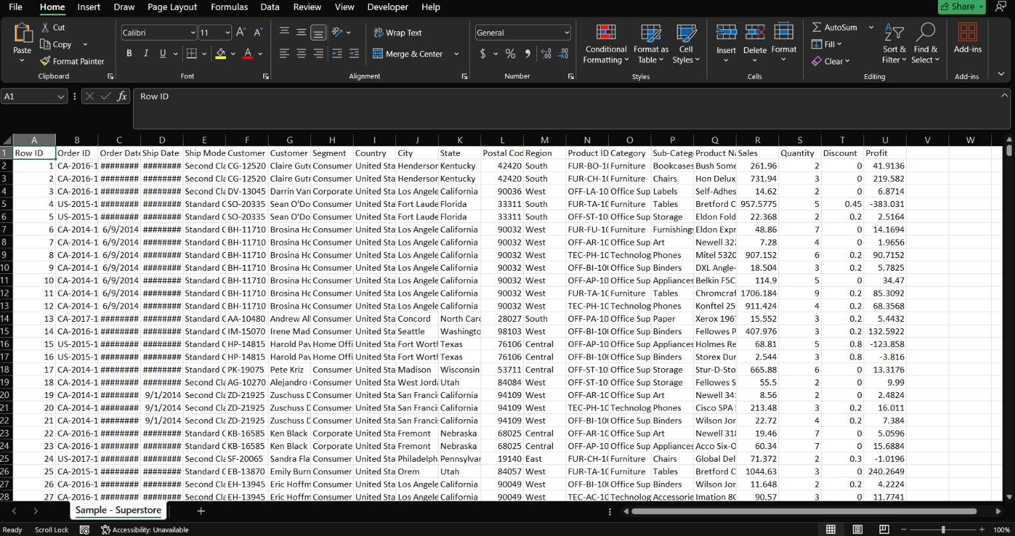
Figure A2. Cleaned Dataset


Appendix B: PostgreSQL Database Implementation
This appendix documents the creation of the PostgreSQL database, the importation of the cleaned dataset, and the validation of the imported records.
Figure B1. PostgreSQL Database

Figure B2. Database Table
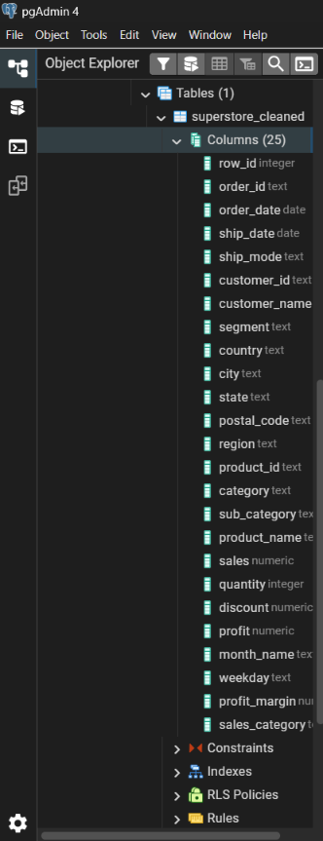
Figure B3. Successful Data Import
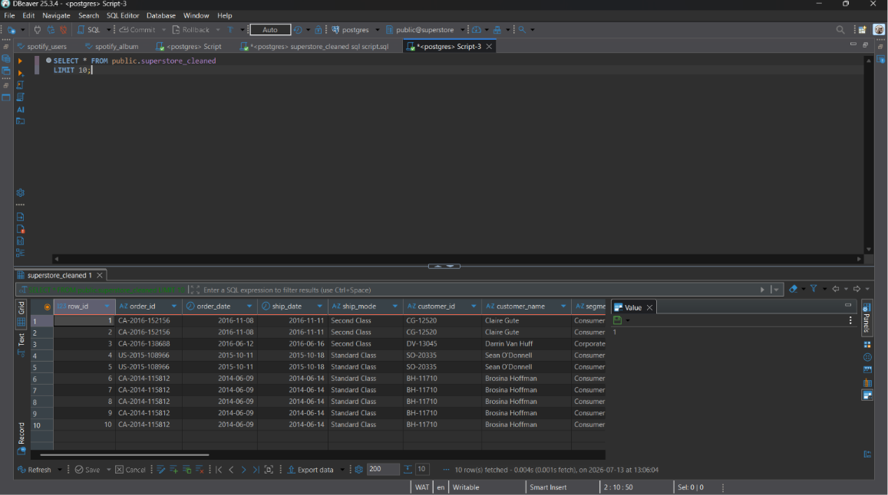
Figure B4. Record Validation
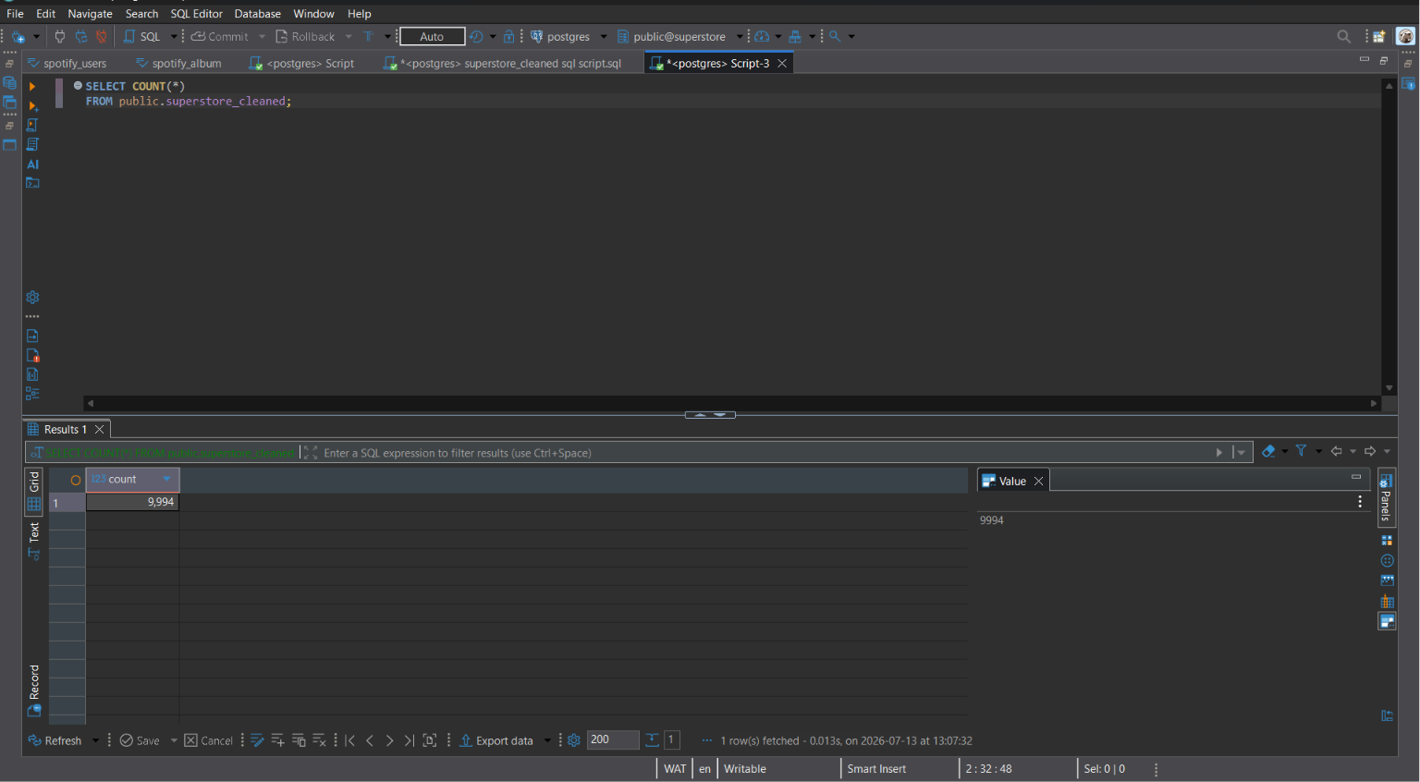

Appendix C: SQL Queries
This appendix contains the SQL queries used during the exploratory data analysis phase to calculate key business metrics and answer analytical questions.
Figure C1. Total Sales Query
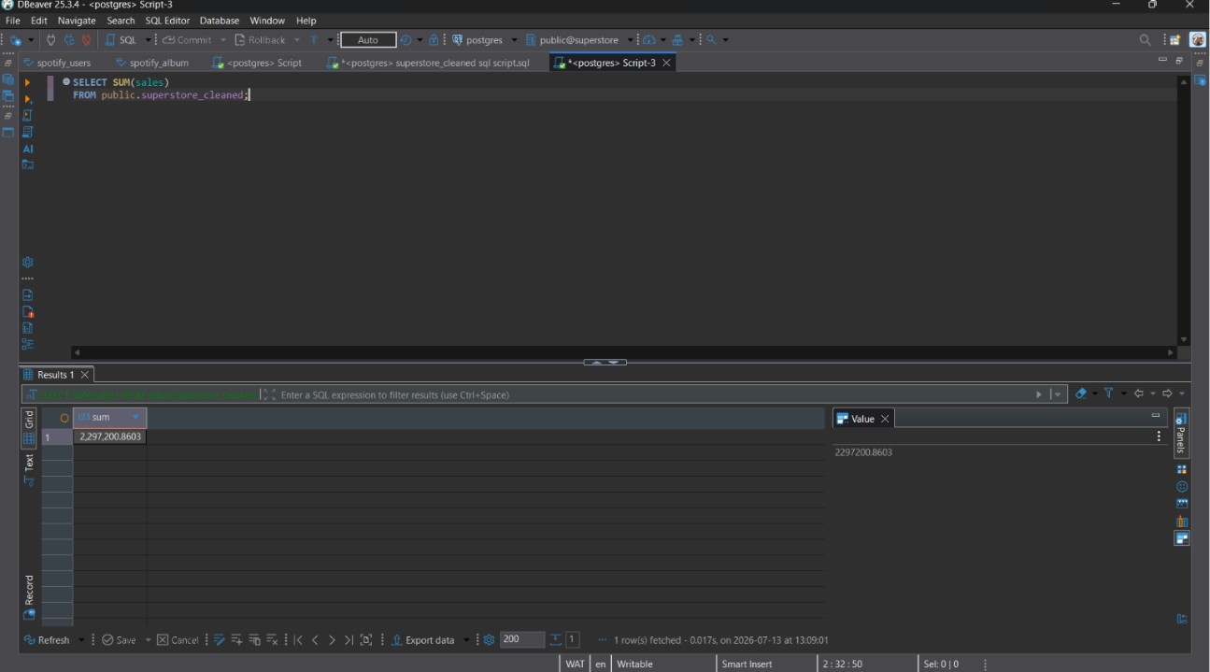

Figure C2. Total Profit Query


Figure C3. Sales by Category
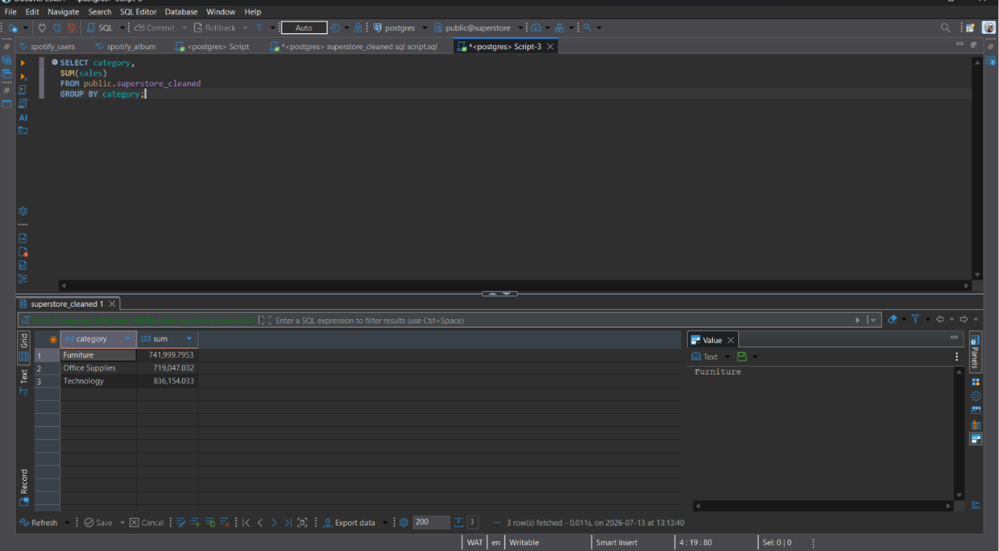

Figure C4. Profit by Region
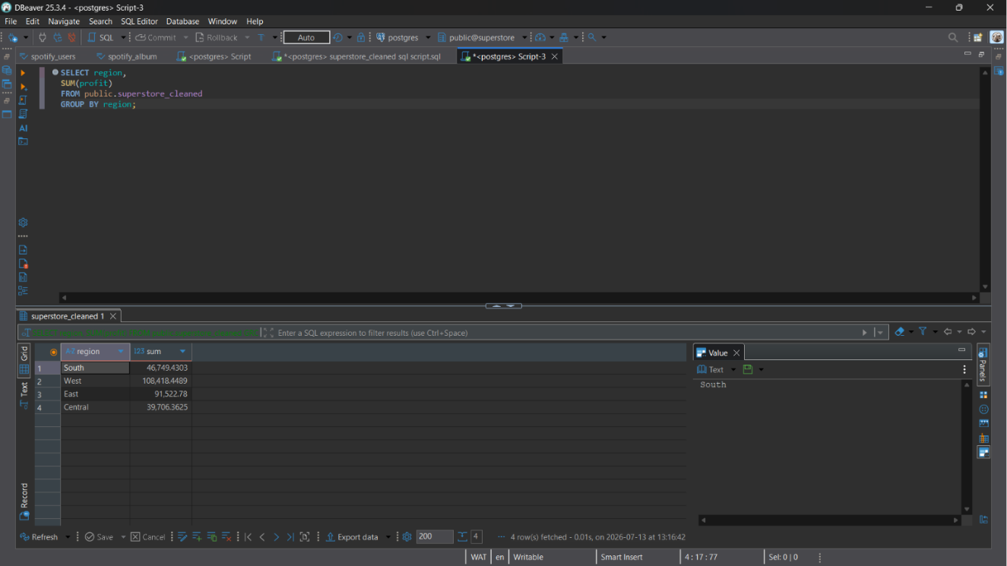

Figure C5. Sales by Customer Segment
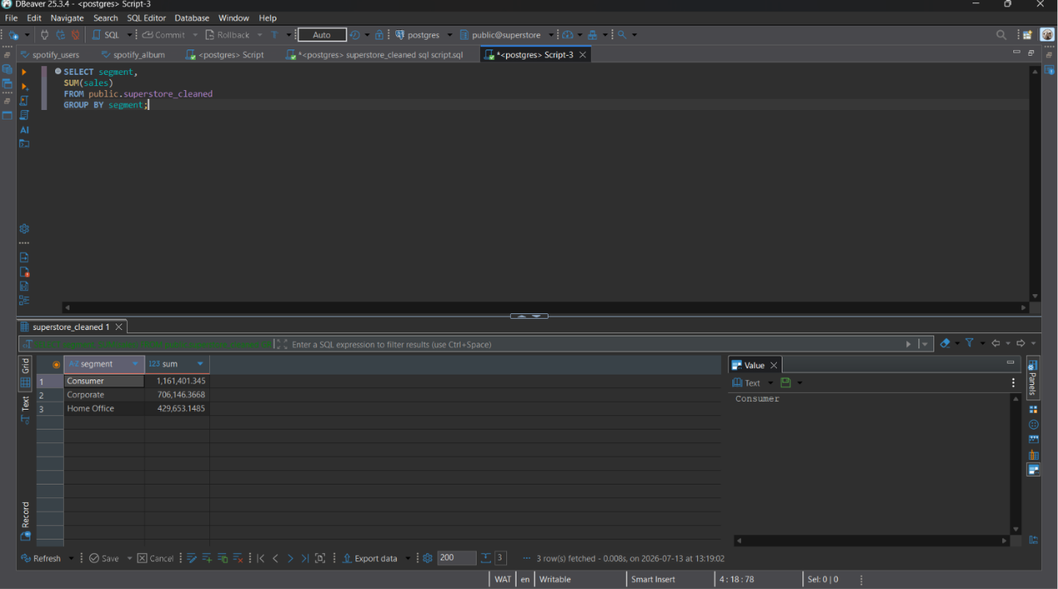
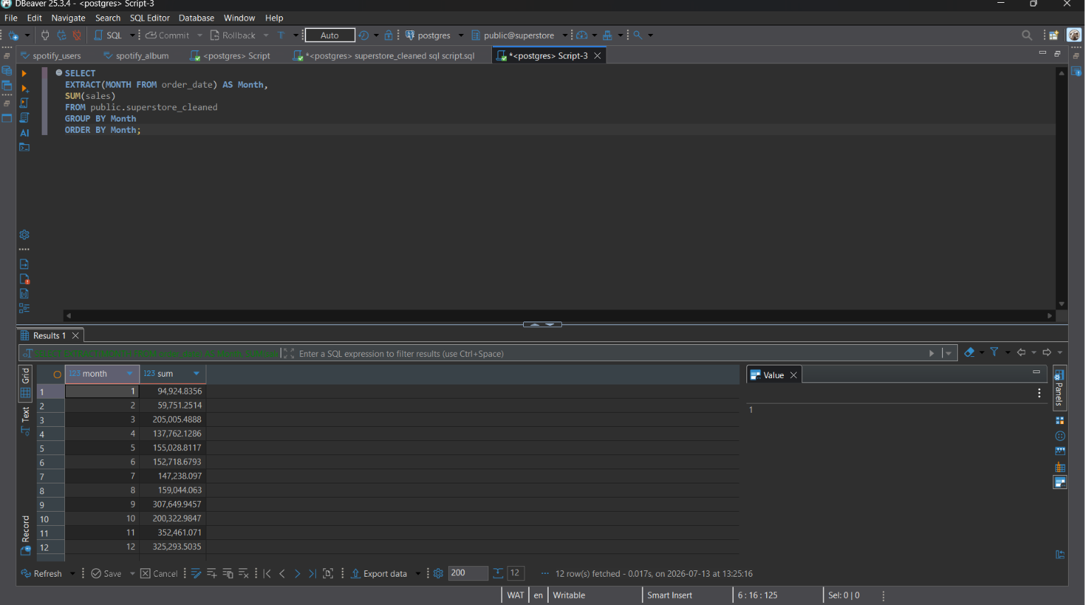
Figure C6. Monthly Sales Trend

Appendix D: DAX Measures
This appendix contains the DAX measures created in Microsoft Power BI to calculate the Key Performance Indicators (KPIs) displayed on the dashboard.
Figure D1. Total Sales Measure
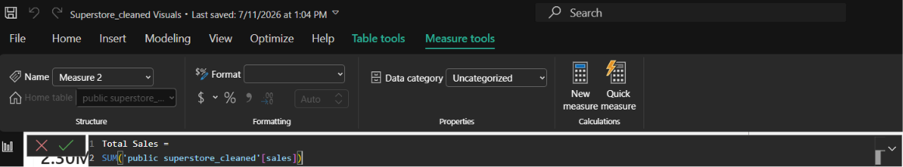

Figure D2. Total Profit Measure
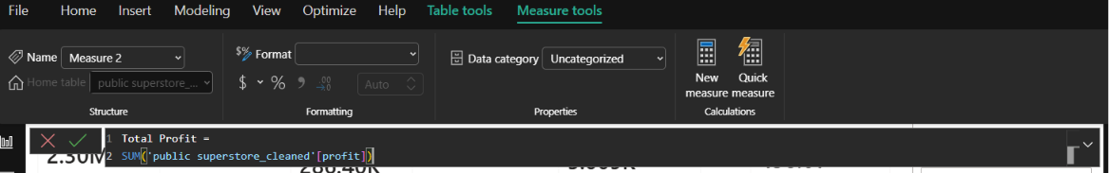

Figure D3. Total Orders Measure
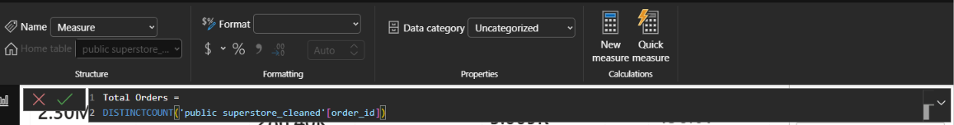

Figure D4. Average Order Value Measure
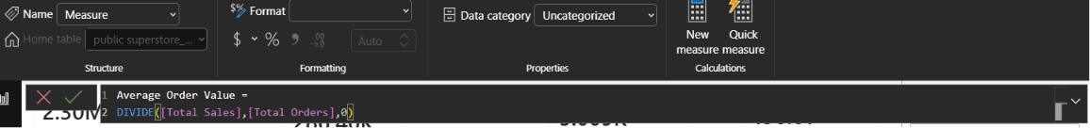

Appendix E: Power BI Dashboards
This appendix presents the completed dashboards developed during the project.
Figure E1. Executive Sales Dashboard


Figure E2. Interactive Dashboard

Figure E3. Business Insights Dashboard


